6.1 Cloud Infrastructure
6.1.1 Cloud Deployment Models
Cloud Deployment Model: classification of ownership and management of a cloud as public, private, community, or hybrid. Categorized as follows:
Public (or Multi-Tenant): service offered over the Internet by cloud service providers (CSP) to cloud consumers.
Cloud Service Providers: organization providing infrastructure, application, and/or storage services via an “as a service” subscription-based, cloud-centric offering.
Multi-Cloud: a cloud deployment model where the cloud consumer uses multiple public cloud services.
Private: cloud that is deployed for use by a single entity.
Cloud Computing: computing architecture where on-demand resources provisioned with the attributes of high availability, scalability, and elasticity are billed to customers on the basis of metered utilization.
Community: cloud that is deployed for shared use by cooperating tenants.
Flexibility is key advantage but implications for data risk must be well understood.
Security Considerations
Single-tenant Architecture: dedicated to a single customer. Highest level of security. More expensive than multi-tenant and the customer is responsible for managing and securing the infrastructure.
Multi-tenant Architecture: multiple customers share the same infrastructure, separated logically from each other. Cost-effective. Increased risk of unauthorized access or data leakage.
Hybrid Architecture: public and private cloud infrastructure. Greater flexibility and control over data. Sensitive data in private cloud and less sensitive in public cloud. Careful management required.
Serverless Architecture: cloud provider manages infrastructure and automatically scales the resources based on demands. More secure than traditional architecture. Provider manages and secures. Customers take steps to secure access to applications and data.
Hybrid Cloud
Cloud deployment that uses both private and public elements.
6.1.2 Cloud Service Models
Classifying the provision of cloud services and the limit of the cloud service provider’s responsibility as software, platform, infrastructure, and so on.
Anything as a Service (XaaS): concept that most types of IT requirements can be deployed as a cloud service model and offered as a subscription-based service.
Software as a Service
Cloud service model that provisions fully developed application services to users. Think of Google Workspace, Office 365, and Salesforce as examples.
Platform as a Service
Cloud service model that provisions application and database services as a platform for the development of apps. Think of Oracle Database, Microsoft Azure SQL Database, and Google App Engine as examples.
Infrastructure as a Service
Cloud service model that provisions virtual machines and network infrastructure. Think of Amazon Elastic Compute Cloud, Microsoft Azure Virtual Machines, Oracle Cloud, and OpenStack as examples.
Third-Party Vendors
External entities that provide organizations with goods, services, or technology solutions.

6.1.3 Responsibility Matrix
Identifies the responsibility for the implementation of security applications, data, and workloads are transitioned into a cloud platform are shared between the customer and the CSP.
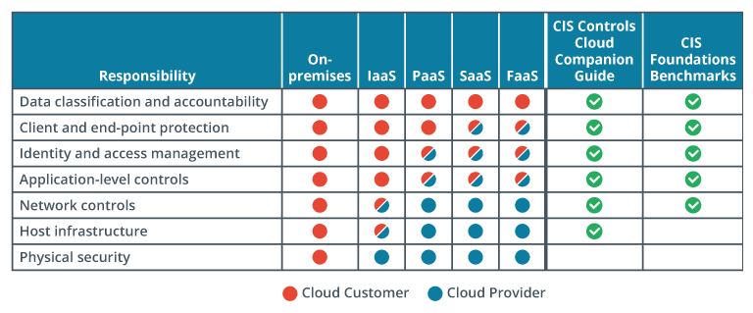
6.1.4 Centralized and Decentralized Computing
Centralized Computing Architecture: model where all data processing and storage is performed in a single location.
Decentralized Computing Architecture: model in which data processing and storage are distributed across multiple locations and services. Some examples are:
Blockchain: distributed ledger technology that allows for secure, transparent, and decentralized transactions.
Peer-to-Peer (P2P) Networks: designed to distribute processing and data storage among participating nodes instead of relying on a central server.
Content Deliver Networks (CDNs): distribute content across multiple servers to improve performance, reliability, and scalability.
Internet of Things (IoT) Devices: connected in a decentralized network to share data and processing power.
Distributed Databases: distribute data across multiple servers, ensuring that data is always available, even if one server goes down.
Tor (The Onion Router): network that enables anonymous communication and browsing. Routes traffic through a network of volunteer-operated servers, or nodes, to hide a user’s location and internet activity.
6.1.5 Resilient Architecture Concepts
Virtualization: computing environment where multiple independent operating systems can be installed to a single hardware platform and run simultaneously. This ensures that availability in the SLA is met.
High Availability (HA): metric that defines how closely systems approach the goal of providing data availability 100% of the time while maintaining a high level of system performance.
Replication: automatically copying data between two processing systems either simultaneously on both systems (synchronous) or from a primary to a secondary location (asynchronous).
Hot Storage v Cold Storage is a reference to how quickly data can be retrieved. The “hotter” the storage, the more expensive.
High Availability Across Zones
CSPs divide the world into regions. Each region is independent of the others. The regions are divided into availability zones. The availability zones have independent datacenters with their own power, cooling, and network connectivity.
Local Replication: replicates your data within a single datacenter in the region where you created your storage account.
Regional Replication (also called zone-redundant storage): replicates your data across multiple datacenters within one or two regions.
Geo-Redundant Storage (GRS): replicates your data to a secondary region that is distant from the primary region.

6.1.6 Application and Container Virtualization
Application Virtualization: software delivery model where the code runs on a server and is streamed to a client.
Containerization: operating system virtualization deployment containing everything required to run a service, application, or microservice.
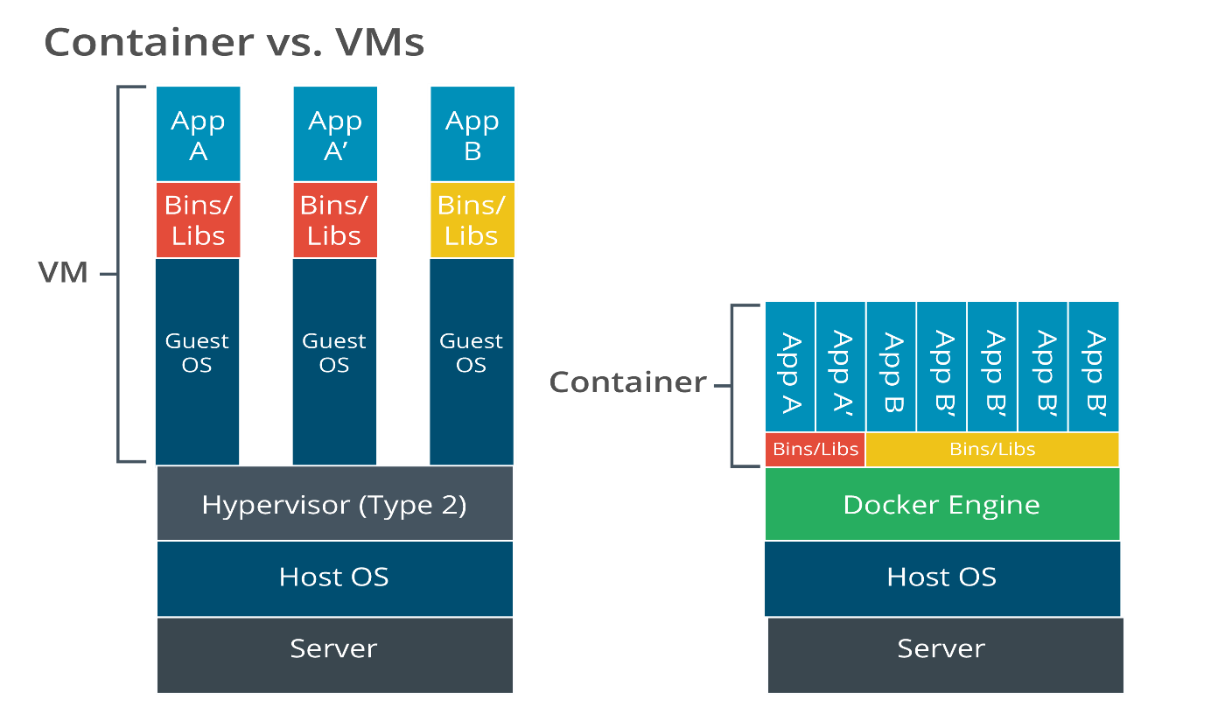
6.1.7 Cloud Architecture
Serverless Computing: features and capabilities of a server without need to perform server administration tasks. Serverless computing offloads infrastructure management to the CSP.
Virtual Private Cloud (VPC): private network segment made available to a single cloud consumer on a public cloud.
Serverless platforms eliminate the need to manage physical or virtual server instances, so there is little to no management effort for software and patches, administration privileges, or file system security monitoring. Serverless architecture depends heavily on event-driven orchestration to facilitate operations.

Microservices: independent, single-function module with well-defined and lightweight interfaces and operations. Typically, this style of architecture allows for rapid, frequent, and reliable delivery of complex applications.
Microservices also enable teams to work independently on different application features, making it easier to scale and update individual components without affecting the entire system. Microservices and Infrastructure as Code (IaC) are related technologies, and Microservices architecture is often implemented using IaC practices. Using IaC, developers can define and deploy infrastructure as code, ensuring consistency and repeatability across different environments.
Transformational Changes: Cloud computing offers many unique architectural services that differ from traditional on-premises services. Cloud-native services allow organizations to scale, innovate, and optimize their operations like never before. Additionally, Cloud platforms provide advanced content delivery networks (CDN) that optimize web traffic by caching content, and object storage provides massive, unstructured data storage services that often replace traditional file servers. Identity and access management tools provide advanced security features and enable new methods of platform integration, while containerization and container orchestration tools are changing how applications are deployed and managed.
6.1.8 Cloud Automation Technologies
Infrastructure as Code: provisioning architecture in which deployment of resources is performed by scripted automation and orchestration.
These files contain code written in a specific format that can be read and executed by machines. These files manage and provision computing infrastructure. Machine-readable definition files are written in formats like YAML, JSON, and HCL (HashiCorp Configuration Language.) These files are typically version-controlled and can be treated like any other code in a software project.
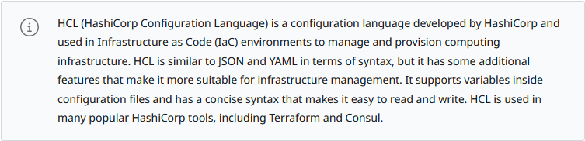
Responsiveness: Load balancing, edge computing, and auto-scaling are critical mechanisms to ensure responsiveness, improve performance, and effectively handle fluctuating workloads.
Load Balancing: distributes network traffic across multiple servers or services to improve performance and provide high availability.
Edge Computing: Optimizes the geographic location of resources and services to enable faster processing and reduced latency. Instead of routing all data to a centralized cloud datacenter, edge computing utilizes distributed computing resources to minimize the distance data needs to travel, reducing network latency and improving responsiveness.
Auto-Scaling: an automated process that adjusts the computing resources allocated to an application based on demand.
6.1.9 Software Defined Networking
IaC is partly facilitated by physical and virtual network appliances that are fully configurable via scripting and APIs.
Management Plane: monitors traffic conditions and network status.
Control Plane: makes decisions about how traffic should be prioritized, secured, and where it should be switched.
Data Plane: handles the switching and routing of traffic and imposition of security access controls.
Software-Defined Networking (SDN): APIs and compatible hardware/virtual appliances allowing for programmable network appliances and systems.
Network Functions Virtualization (NFV): provisioning virtual network appliances, such as switches, routers, and firewalls, via VMs and containers. This architecture saves network and security administrators the job and complexity of configuring appliance settings properly to enforce a desired policy.
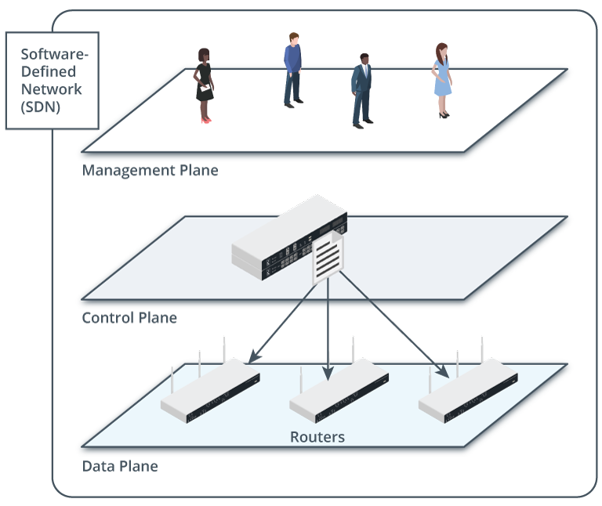
6.1.10 Cloud Architecture Features
Public cloud infrastructure provides a wide range of available features to ensure high uptime and minimal downtime for its customers. Public cloud providers offer disaster recovery services, including monitoring and alerting tools, to proactively detect and respond to any issues that could impact availability. Public cloud providers also typically offer service-level agreements (SLAs) that guarantee a certain level of uptime and availability, including credits or refunds if the provider fails to meet availability commitments.
Considerations
Cost: Should focus on solutions that best achieve operational goals while maintaining the confidentiality, integrity, and availability of data, not simply cost in cloud adoption. Using cloud services involves a shift from capital expenses (CapEx) to operational expenses (OpEx).
Scalability: one of the most valuable and compelling features of cloud computing. Scale-up (vertical scaling) describes adding capacity to an existing resource, such as a processor, memory, and storage capacity. Scale-out (horizontal scaling) describes adding additional resources, such as more instances (or virtual machines) to work in parallel and increase performance.
Resilience: Cloud providers use redundant hardware, fault tolerance capabilities (such as clustering), and data replication to store data across multiple servers and datacenters, ensuring that data remains available if one server or datacenter fails.
Ease of Deployment: Cloud features supporting ease of deployment include automation, standardization, and portability.
Automation of the deployment and management of cloud services.
Standardization of configurations, templates, and images.
Portability to ensure that applications and services can be easily moved.
Ease of Recovery: Cloud providers typically offer backup and restore functionality to allow organizations to schedule automated backups and quickly restore data in case of accidental deletion, corruption, or system failures.
SLA and ISA: Service level agreements (SLAs) define expected service levels, including performance, availability, and support commitments between cloud service providers and organizations. Interconnection Security Agreements (ISAs) establish the security requirements and responsibilities between the organization and the cloud service provider to safeguard sensitive data and ensure compliance with industry regulations to help ensure the confidentiality, integrity, and availability of data and systems within the cloud environment. Regulated industries must ensure that their cloud service provider complies with relevant regulations, such as GDPR, HIPAA, or PCI DSS, and the ISA must detail how the provider meets these compliance requirements and include provisions for auditing and reporting to demonstrate ongoing compliance.
Power: Cloud providers prioritize energy efficiency to reduce costs and environmental impact by deploying energy-efficient hardware, optimizing cooling systems, and implementing power management techniques. Power usage effectiveness (PUE) is a metric used to measure datacenter energy efficiency.
Compute: compute capabilities in cloud architecture provide the flexibility, scalability, and efficiency necessary to manage and utilize computing resources. Compute capabilities include elasticity, resource pooling, orchestration, automation, and serverless computing, which contribute to delivering highly available, scalable, and cost-effective computing environments in the cloud.
6.1.11 Cloud Security Considerations
Data Protection: data and applications are stored outside of an organization's privately managed infrastructure and are essentially stored "on the Internet" which means that configuration mistakes can have disastrous consequences.
Patching: cloud providers should have a clear policy regarding patch management, including how often patches are released and how quickly the provider will respond to critical vulnerabilities.
Secure Communication and Access
Software-Defined Wide Area Network (SD-WAN): Services that use software-defined mechanisms and routing policies to implement virtual tunnels and overlay networks over multiple types of transport network. One of the key advantages of SD-WAN is its ability to provide enhanced security features and considerations.
Secure Access Service Edge (SASE): networking and security architecture that provides secure access to cloud applications and services while reducing complexity. It combines security services like firewalls, identity and access management, and secure web gateway with networking services such as SD-WAN.
6.2 Embedded Systems and Zero Trust Architecture
6.2.1 Embedded Systems: electronic system that is designed to perform a specific, dedicated function, such as a microcontroller in a medical drip or components in a control system managing a water treatment plant.
Real-Time Operating Systems (RTOS): type of OS that prioritizes deterministic execution of operations to ensure consistent response for time-critical tasks.
The VxWorks operating system is commonly used in aerospace and defense systems. VxWorks provides real-time performance and reliability and is therefore well suited for use in aircraft control systems, missile guidance systems, and other critical defense systems.
Risks Associated with RTOS: A security breach involving RTOS can have serious consequences. RTOS software can be complex and difficult to secure, which makes it challenging to identify and address vulnerabilities that could be exploited by attackers. Another security risk associated with RTOS is the potential for system-level attacks. An attacker who gains access to an RTOS-based system could potentially disrupt critical processes or gain control over the system it is designed to control.
6.2.2 Industrial Control Systems
Workflow and Process Automation Systems
Industrial Control Systems (ICS): network managing embedded devices (computer systems that are designed to perform a specific, dedicated function). An ICS that manages process automation within a single site is usually referred to as a distributed control system (DCS).
Operational Technology (OT): communications network designed to implement an industrial control system rather than data networking.
Human-Machine Interfaces (HMIs): input and output controls on a PLC to allow a user to configure and monitor the system. An HMI might be a local control panel or software running on a computing host.
Data Historian: software that aggregates and catalogs data from multiple sources within an industrial control system. A database of all the information the control loop generated.
Supervisory Control and Data Acquisition (SCADA)
Type of industrial control system that manages large-scale, multiple-site devices and equipment spread over geographically large areas from a host computer.
ICS/SCADA Applications
Energy: refers to power generation and distribution.
Industrial: can refer specifically to mining and refining raw materials, involving hazardous high heat and pressure furnaces, presses, centrifuges, pumps, and so on.
Fabrication and Manufacturing: refer to creating components and assembling them into products.
Logistics: refers to moving things from where they were made or assembled to where they need to be, either within a factory or for distribution to customers.
Facilities: refer to site and building management systems, typically operating automated heating, ventilation, and air conditioning (HVAC), lighting, and security systems.
Cybersecurity is paramount in Industrial Control Systems (ICS) and Supervisory Control and Data Acquisition (SCADA) systems. These systems are associated with critical infrastructure sectors such as energy, manufacturing, transportation, and water treatment. Cyberattacks on these systems can severely impact public safety, economic stability, and national security.
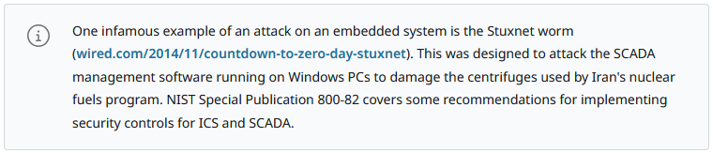
6.2.3 Internet of Things
Devices that can report state and configuration data and be remotely managed over IP networks.
IoT Examples
There are many IoT devices and applications in use today. For example, smart homes often use IoT sensors and actuators to control lighting, temperature, and security systems, allowing homeowners to monitor and adjust their homes remotely.
Factors Driving Adoption of IoT
Several factors drive the rapid adoption of IoT. The significantly decreased cost of IoT sensors and devices over the past few years has made them more affordable and accessible to businesses and consumers. Advances in connectivity technology, such as 5G and low-power wireless networks, have made connecting and managing large numbers of IoT devices easier and more efficient. The proverbial explosion of data generated by IoT devices has led to new data analytics tools and techniques, such as machine learning and artificial intelligence, that help organizations analyze vast amounts of data and extract valuable insights. The COVID-19 pandemic has accelerated the adoption of IoT in many industries, particularly in healthcare, where remote monitoring and telemedicine have become increasingly important.
Security Risks Associated with IoT
There are several significant security risks associated with IoT. One major risk is the large number of IoT devices deployed without adequate security measures. Many IoT devices are designed with limited processing power and memory, making it difficult to implement strong security controls. This can make them vulnerable to cyberattacks, compromising data privacy, system integrity, and physical safety
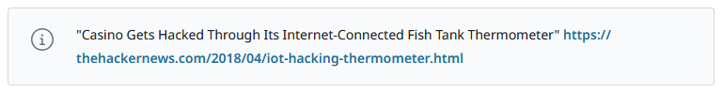
Best Practice Guidance for IoT
The following provide guidance regarding the secure implementation of IoT:
- The Internet of Things Security Foundation (IoTSF) - https://iotsecurityfoundation.org
- Industrial Internet Consortium (IIC) Security Framework - https://www.iiconsortium.org/iisf/
- Cloud Security Alliance (CSA) IoT Security Controls Framework - https://cloudsecurityalliance.org/artifacts/iot-security-controls-framework
- European Telecommunications Standards Institute (ETSI) IoT Security Standards - https://www.etsi.org/technologies/consumer-iot-security
6.2.4 Deperimeterization and Zero Trust
The Emerging Need for Zero Trust Architectures (ZTA)
Zero Trust: The security design paradigm where any request (host-to-host or container-to-container) must be authenticated before being allowed.
NIST SP 800-207 "Zero Trust Architecture" defines Zero Trust as "cybersecurity paradigms that move defenses from static, network-based perimeters to focus on users, assets, and resources."
- NIST SP 800-207 https://csrc.nist.gov/publications/detail/sp/800-207/final.
- CISA's Zero Trust Maturity Model https://www.cisa.gov/zero-trust-maturity-model
Deperimeterization
Deperimeterization refers to a security approach that shifts the focus from defending a network's boundaries to protecting individual resources and data within the network. Deperimeterization concepts advocate for implementing multiple security measures around individual assets, such as data, applications, and services.
Trends Driving Deperimeterization
Cloud: enterprise infrastructures are typically spread between on-premises and cloud platforms.
Remote Work: more and more organizations have adopted either part-time or full-time remote workforces.
Mobile: modern smartphones and tablets are often used as primary computing devices as they have ample processor, memory, and storage capacity.
Outsourcing and Contracting: support arrangements often provide remote access to external entities, and this access can often mean that the external provider's network serves as an entry point to the organizations they support.
Wireless Network (Wi-Fi): wireless networks are susceptible to an ever-increasing array of exploits, but oftentimes wireless networks are open and unsecured or the network security key is well known.

The Key Benefit of a Zero Trust Architecture
Greater security—Requires all users, devices, and applications to be authenticated and verified before network access.
Better access controls—Include more stringent limits regarding who or what can access resources and from what locations.
Improved governance and compliance—Limit data access and provide greater operational visibility on user and device activity.
Increased granularity—Grants users access to what they need when they need it.
A Zero Trust architecture requires a thorough understanding of the many components and technologies used within an organization's network. The following list outlines the essential components of a Zero Trust architecture:
Network and endpoint security—Controls access to applications, data, and networks.
Identity and access management (IAM)—Ensures only verified users can access systems and data.
Policy-based enforcement—Restricts network traffic to only legitimate requests.
Cloud security—Manages access to cloud-based applications, services, and data.
Network visibility—Analyzes network traffic and devices for suspicious activity.
Network segmentation—Controls access to sensitive data and capabilities from trusted locations.
Data protection—Controls and secures access to sensitive data, including encryption and auditing.
Threat detection and prevention—Identifies and prevents attacks against the network and the systems connected to it.

6.2.5 Zero Trust Security Concepts
Zero trust is a security model that assumes that all devices, users, and services are not inherently trusted, regardless of whether inside or outside a network's perimeter. Instead, the zero trust model requires all users and devices to be authenticated and authorized before accessing network resources. The zero trust model includes several fundamental concepts that provide a comprehensive security solution.
Adaptive identity recognizes that user identities are not static and that identity verification must be continuous and based on a user's current context and the resources they are attempting to access.
Threat scope reduction means that access to network resources is granted on a need-to-know basis, and access is limited to only those resources required to complete a specific task. This concept reduces the network's attack surface and limits the damage that a successful attack can cause.
Policy-driven access control describes how access control policies are used to enforce access restrictions based on user identity, device posture, and network context.
Significance of Control and Data Planes in Zero Trust
In a zero trust architecture, the control and data planes are implemented separately and have different functions.

Components in NIST's Zero Trust Architecture Framework
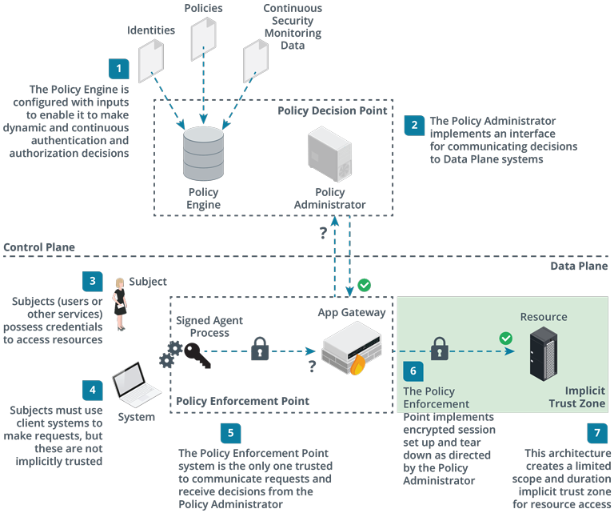
The data plane manages policies that dictate how users and devices are authorized to access network resources. It is implemented through a centralized policy decision point. The policy decision point is responsible for defining policies that limit access to resources on a need-to-know basis, monitoring network activity for suspicious behavior, and updating policies to reflect changing network conditions and security threats. The policy decision point is comprised of two subsystems:
The policy engine is configured with subject and host identities and credentials, access control policies, up-to-date threat intelligence, behavioral analytics, and other results of host and network security scanning and monitoring. This comprehensive state data allows it to define an algorithm and metrics for making dynamic authentication and authorization decisions on a per-request basis.
The policy administrator is responsible for managing the process of issuing access tokens and establishing or tearing down sessions, based on the decisions made by the policy engine. The policy administrator implements an interface between the control plane and the data plane.
The goal of zero trust design is to make this implicit trust zone as small as possible and as transient as possible. Trusted sessions might only be established for individual transactions. This granular or microsegmented approach is in contrast with perimeter-based models, where trust is assumed once a user has authenticated and joined the network. In zero trust, place in the network is not a sufficient reason to trust a subject request. Similarly, even if a user is nominally authenticated, behavioral analytics might cause a request to be blocked or a session to be terminated.
Zero Trus Architecture Examples
Example | Description
Google BeyondCorp | Google's BeyondCorp is a widely recognized example of a zero trust security architecture. BeyondCorp uses a system of multiple security layers, including identity verification, device verification, and access control policies, to secure Google's internal network. This has enabled Google to provide its employees with remote access to company resources while maintaining high security.
Cisco Zero Trust Architecture | Cisco has developed a comprehensive zero trust security architecture incorporating network segmentation, access control policies, and threat detection and response capabilities. The architecture is designed to protect against a wide range of cyber threats, including insider threats and external attacks.
Palo Alto Networks Prisma Access | Prisma Access is a cloud-delivered security service that uses a zero trust architecture to secure network traffic. It provides secure access to cloud and Internet resources while also preventing data exfiltration and other cyber threats.

